|  |
| --- |
| Avocado  Manufacturing Guide |
| Wildcat Robot Design Studio  Winter/Spring 2018  Akash Borde, Tsong Chen, Rachel Hughes, Weilin Ma, Ryan Miller, Nathan Shelly, Allen Tang  Akash Borde, Tsong Chen, Rachel Hughes, Weilin Ma, Ryan Miller, Nathan Shelly, Allen Tang  Akash Borde, Tsong Chen, Rachel Hughes, Weilin Ma, Ryan Miller, Nathan Shelly, Allen Tang  Akash Borde, Tsong Chen, Rachel Hughes, Weilin Ma, Ryan Miller, Nathan Shelly, Allen Tang |

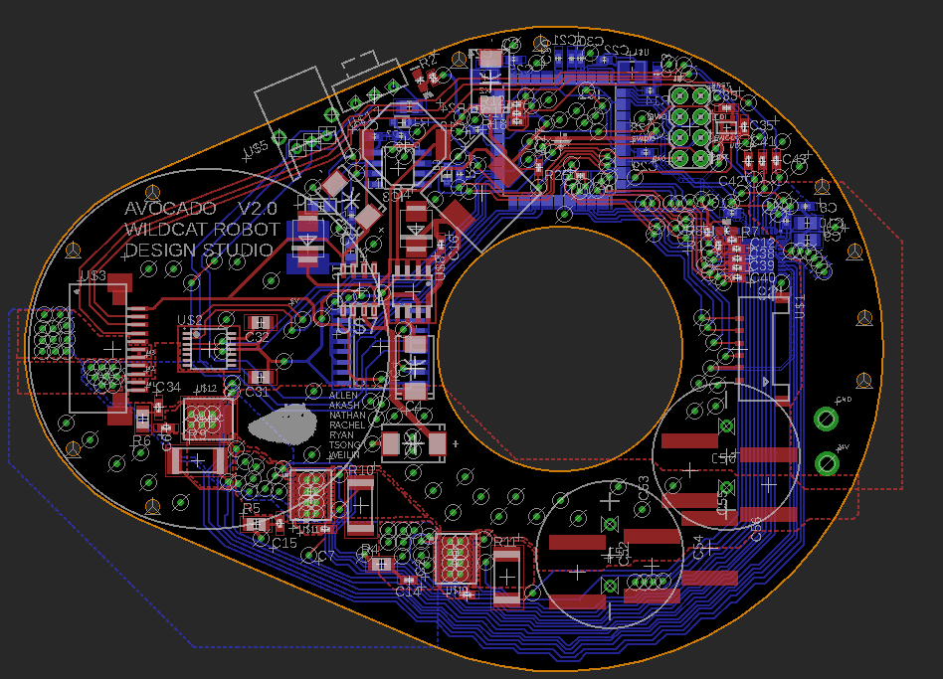



Table of Contents

Manufacturing the Avocado 3

Mechanical Manufacturing 3

Electrical Assembly 13

Total Assembly 19

Bill of Materials 28

Mechanical 28

Electrical 29

# Manufacturing the Avocado

The following documentation details the manufacturing processes and setup required to create an Avocado. The procedures are divided into subsections of mechanical manufacturing, electrical assembly, and total assembly. For the complete Bill of Materials, see page 28.

### Mechanical Manufacturing

#### Gearing

##### Injection Molding

###### Output Gear and Shaft [G1]

The output gear and shaft were SLA printed on a FormLab 2 printer. For larger-scale manufacturing, the part could be injection molded with extensive coring along the gear face. Changes would need to be made to the design of the output gear to accommodate an injection molding process, although it would likely be the best large-scale procedure. A quote from a manufacturing company, Protolabs, highlights the changes required on the design to accommodate their injection molding equipment and gives a breakdown of tooling cost. This quote along with their suggested changes can be found [here](Injection%20Molding%20Edits-%20Protolabs.pdf). The current design as used in the 3D printer can be found [here](CAD/outputGear.PDF), as well as in Figure 1, below.

Figure 1: Drawing of output gear

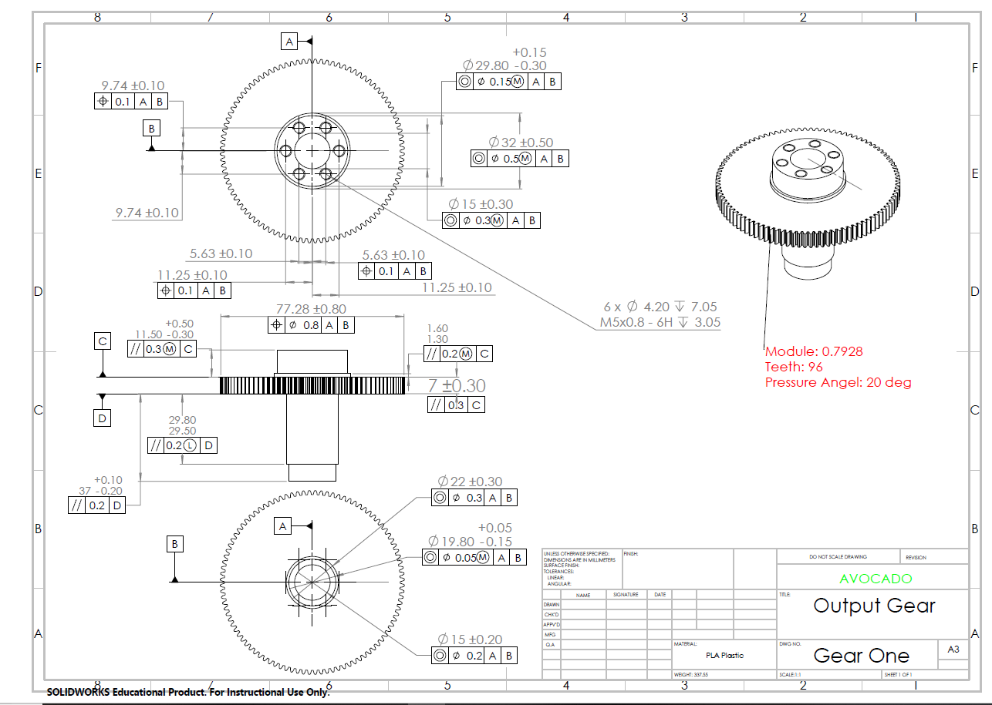

##### Pinion Gear [G2]

The pinion gear comes with a 3mm diameter bore hole. A lathe is recommended to machine the bore hole size. The pinion hub can be fixed in a 19/64 chuck. Drill through using a #24 or #25 drill or some equivalent roughly 0.1mm less than the final size. Repeat the operation with a 4mm reamer.

For proper motor mounting, it is recommended to use a Dremel on the motor shaft to create a flat for the set screw, which comes with the pinion.

#### Housing Plates

##### CNC Operations

###### Middle Plate [HS3]

Stock: 6061 Aluminum, 1” thick, 6” x 7”

Tools (in order):

1. 2-flute 0.5” flat endmill, HSS
2. #2 Center drill, HSS
3. #29 drill
4. #40 drill
5. 2-flute 0.25” flat endmill, HSS

Note: Manufacturing was performed on a HAAS super mini-mill.

Setup:

1. Clamp the stock into the machine and set zeros such that x- and y-zeros are at the center of the stock and z-zero is at the surface of the stock. It is recommended to have the stock on 0.75” parallels.
2. The first operation consists of machining a pocket for the entire part, the large inner pocket, the smaller pocketed features such as the encoder hole and motor mounting holes, and the smaller attachment holes around the perimeter.
3. The part is then transferred to a second setup, where the stock is flipped along the x-axis and fixtured the same as before in the vice.
4. The second operation consists of drilling the attachment holes along the perimeter and machining a pocket 0.05” away from the part, leaving fingers for fixturing and ease of removal.
5. The finish passes close in on the exact part dimension, and the part can be separated from the fingers after removal.

The design of the middle housing plate is according to Figure 2, below, and is also located [here](CAD/SafeMid.PDF).

Figure 2: Drawing of middle plate

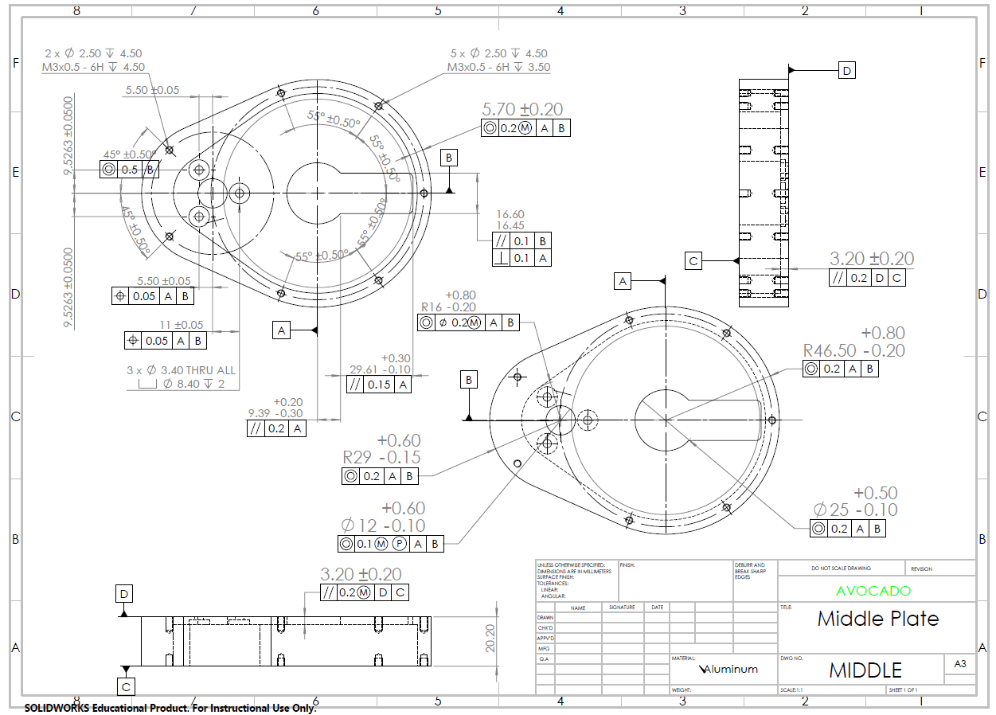

###### Bottom Plate [HS4]

The bottom plate is machined similarly to the middle plate.

Stock: 6061 Aluminum, 0.25” thick, 6” x 7”

Tools:

1. 2-flute 0.5” flat endmill, HSS
2. #2 Center drill, HSS
3. #40 drill
4. #16 drill
5. 2-flute 0.25” flat endmill, HSS

Setup:

1. Clamp the stock into the machine and set zeros such that x- and y-zeros are at the center of the stock and z-zero is at the surface of the stock. It is recommended to have the stock on 0.75” parallels.
2. The operation consists of machining a pocket for the entire part, the bore hole and bearing seat, and the drill holes for mounting, both around the edge and around the output hole. Fingers are left similarly to the middle plate for ease of removal.

The design of the bottom housing plate is according to Figure 3, below, and is also located [here](CAD/SafeBot.PDF).

Figure 3: Drawing of bottom plate

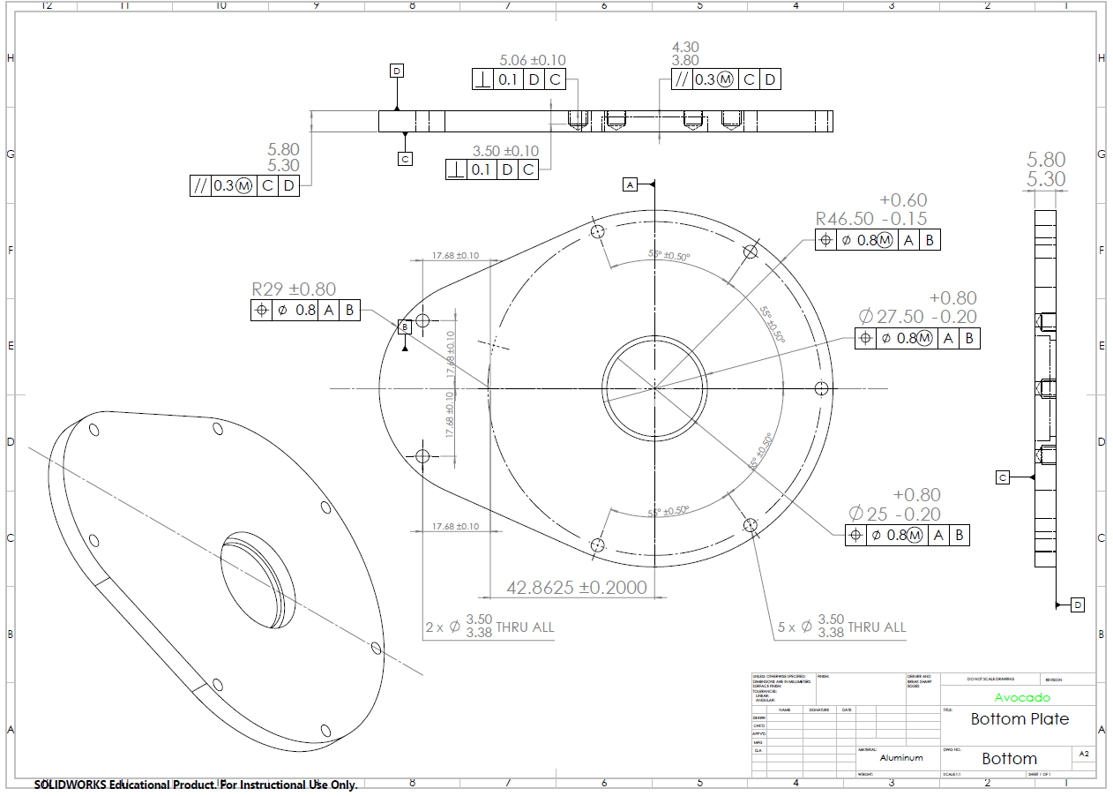

###### Top Plate [HS2]

The top plate is machined similarly to the middle plate.

Stock: 6061 Aluminum, 0.25” thick, 6” x 7”

Tools:

1. 2-flute 0.5” flat endmill, HSS
2. #2 Center drill, HSS
3. 2-flute 0.25” flat endmill, HSS

Setup:

1. Clamp the stock into the machine and set zeros such that x- and y-zeros are at the center of the stock and z-zero is at the surface of the stock. It is recommended to have the stock on 0.75” parallels.
2. The operation consists of machining a pocket for the entire part, the bore hole and bearing seat, and the drill holes around the edge for mounting. Fingers are left similarly to the other plates for ease of removal.

The design of the top housing plate is according to Figure 4, below, and is also located [here](CAD/SafeTop.PDF).

Figure 4: Drawing of top plate

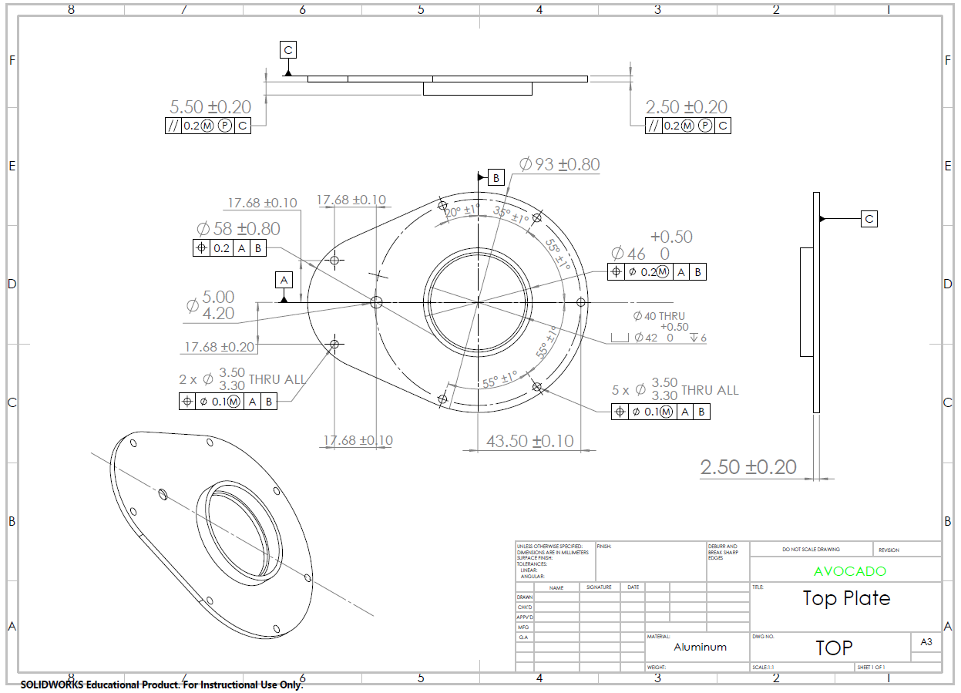

##### Additional Procedures

###### Fasteners

There are several screw holes on the plates that require hand-tapping. The positions of these holes are shown in the previous Figures 2, 3 and 4. All three housing plates have tapped holes.

###### Optical Encoder Plate

The optical encoder plate is printed onto standard sticker paper and cut out. The cut out optical disk sticker is then adhered to the base of the output gear, as shown in Figure 5, below. The correctly dimensioned optical disk can be found [here](OpticalEncoder.png).

Figure 5: Optical Disk Assembly

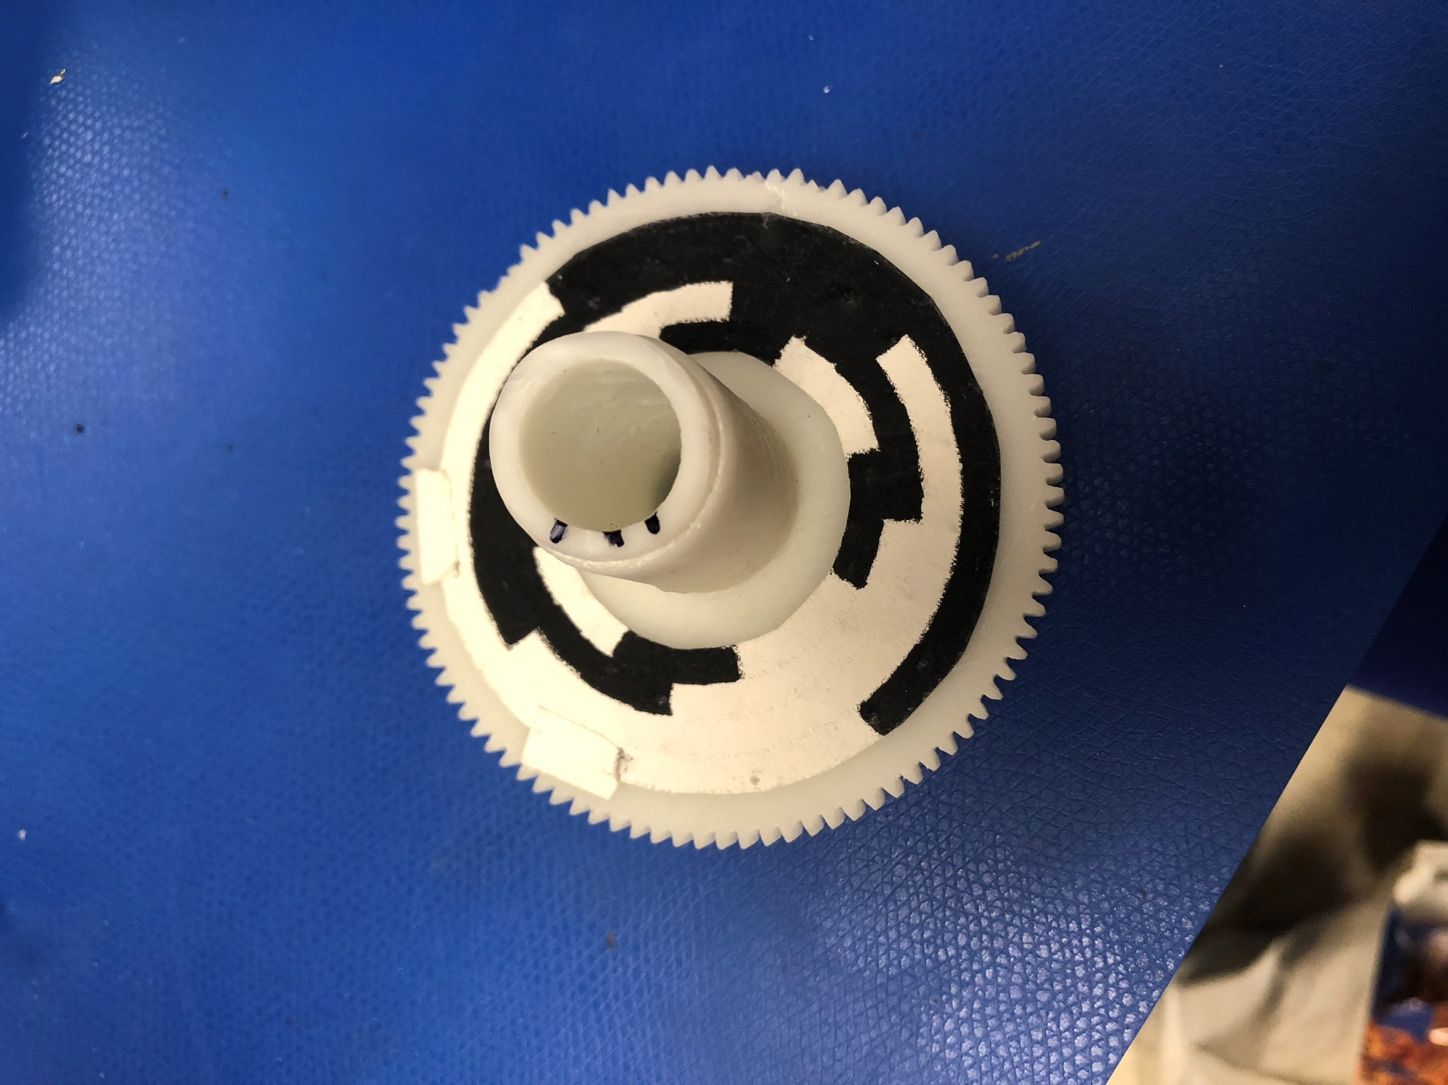

### Electrical Assembly

The Avocado has two circuit boards that control its operation: The Main PCB (Avocado_v2.0), and a separate Optical Encoder board (optical_encoder) connected by a 6-pin Pico Lock connector. These circuits contain all the circuitry needed for sensing, motor control, and communication.

The circuit schematics and overlays provide the user a reference for how the PCB is intended to operate; the BOM and Gerber files are provided as a reference for the user to create their own Avocado circuitry.

The Gerber files can be found [here](Gerber%20Files).

#### Schematics:

The two electrical schematics contain the overall circuit diagrams for the main PCB [PCB1] and optical encoder PCB [PCB2]. Of the two, the main PCB schematic is the more complicated, and is broken down into several subsystem schematics: Power (Voltage Regulators), RS485 (Communication), Encoder (Position Sensing), Motor (Motor Control), Temperature (Thermocouple and Ambient Temperature Sensor), and MCU (Microcontroller Circuitry).

The Optical Encoder Schematic is straightforward -- it only has one set of 4 optical encoding bits that correspond to a custom encoder pattern mounted on the output gear.

#### PCB Overlays:

4 overlays are provided for PCB populating/debugging, which explain what pads connect to each other, and what electrical components mount to the circuit board and where. The electrical components have a custom part numbering that is referenced in the BOM on page 29.

The following Figures 6-11 show the schematics and overlays of the Avocado PCBs, although the full pdf versions are located at the following links:

[Main PCB Top Overlay](avocado_v2.0_top_overlay.pdf)

[Main PCB Bottom Overlay](avocado_v2.0_bottom_overlay.pdf)

[Main PCB Schematic](avocado_v2.0_schematic.pdf)

[Optical Encoder Top Overlay](optical_encoder_top_overlay.pdf)

[Optical Encoder Bottom Overlay](optical_encoder_bottom_overlay.pdf)

[Optical Encoder Schematic](optical_encoder_schematic.pdf)

###### Main PCB:

Figure 6: Main PCB top overlay

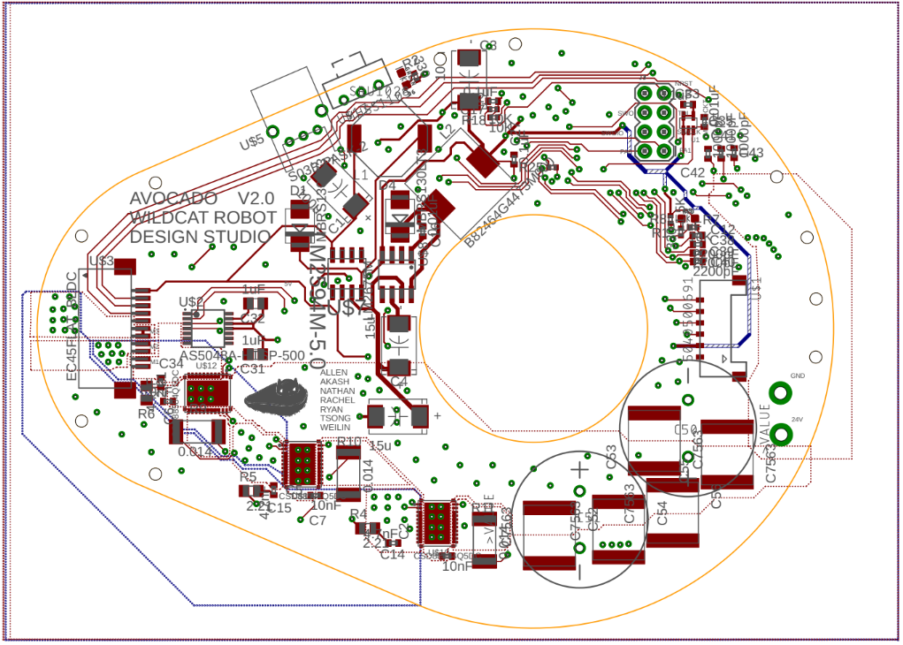

Figure 7: Main PCB bottom overlay

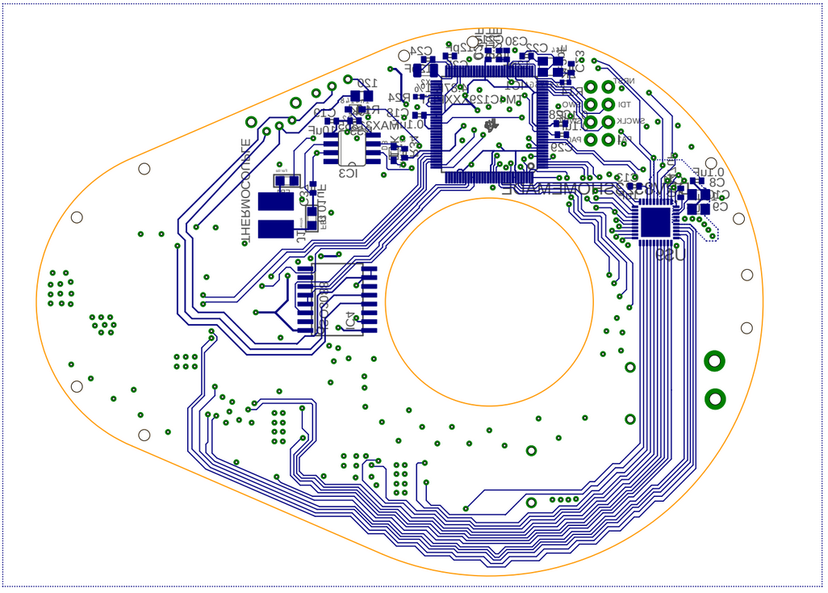

Figure 8: Main PCB schematic

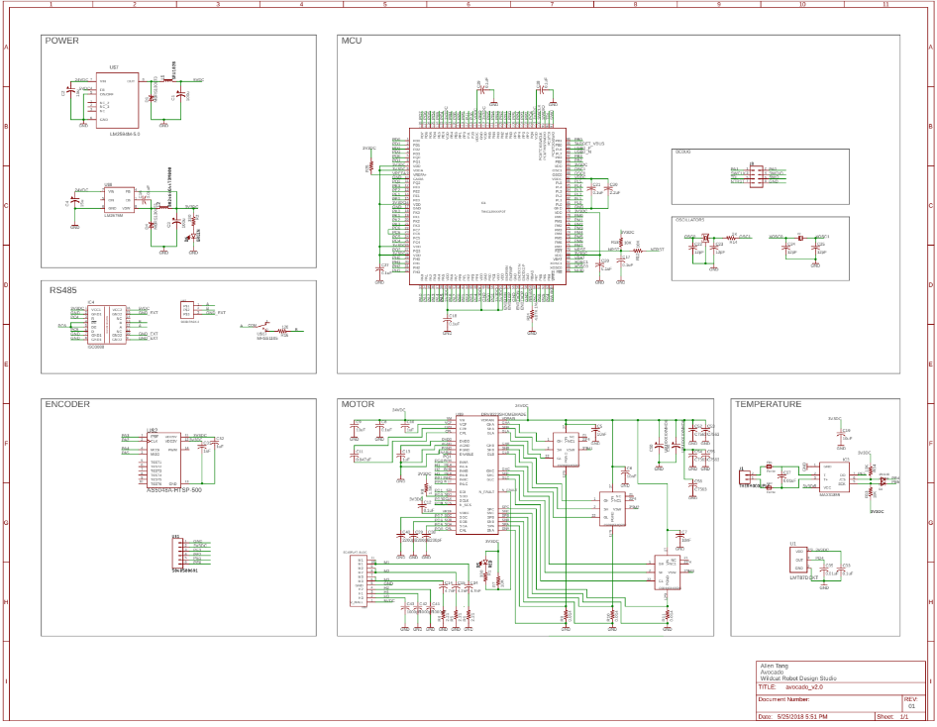

###### Optical Encoder PCB:

    Figure 9: Optical Encoder top overlay

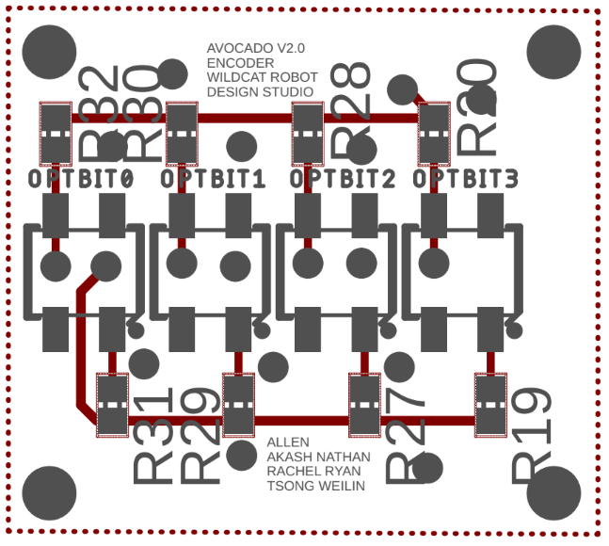

Figure 10: Optical Encoder bottom overlay

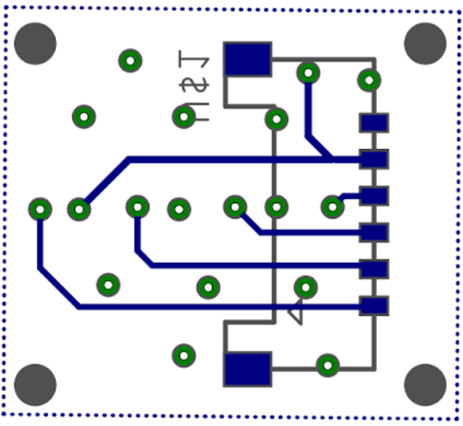

Figure 11: Optical Encoder schematic

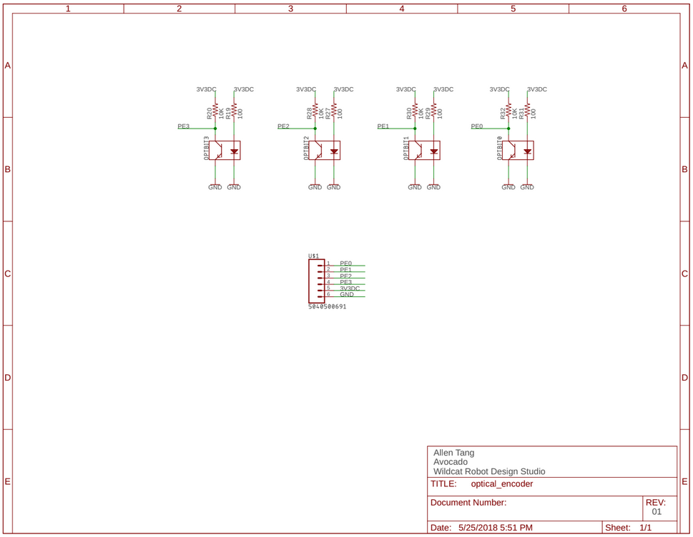

#### Gerber Files

The Gerber files are available, as stated earlier, [here](Gerber%20Files).

### Total Assembly

#### Procedure

The following is a procedural list of instructions to assemble the Avocado. The part list for assembly is as follows:

* HS2: Top Cap
* HS3: Middle Plate
* HS4: Bottom Plate
* 10 FS3: M3 screws
* 6 FS5: M5 screws
* 7 S1: 25mm standoffs
* 3 FS1.4: 3 M1.4 screws
* PCB1: Main PCB
* PCB2: Optical Encoder PCB
* B1: Large Bearing
* B2: Small Bearing
* G1: Pinion gear (with set screw)
* G2: Output Gear and Shaft with Optical Plate
* M1: Motor

For further reference, videos of the exploded assembly can be found [here](CAD/Explode.avi) and [here](CAD/Collapse.avi).

1. Starting from the top, insert B1 into the bearing seat of HS2 with a press for a tight press fit, then insert the output rotor portion of G2 into the bearing, as shown in Figure 12.

Figure 12: Bearing and output rotor in top cap

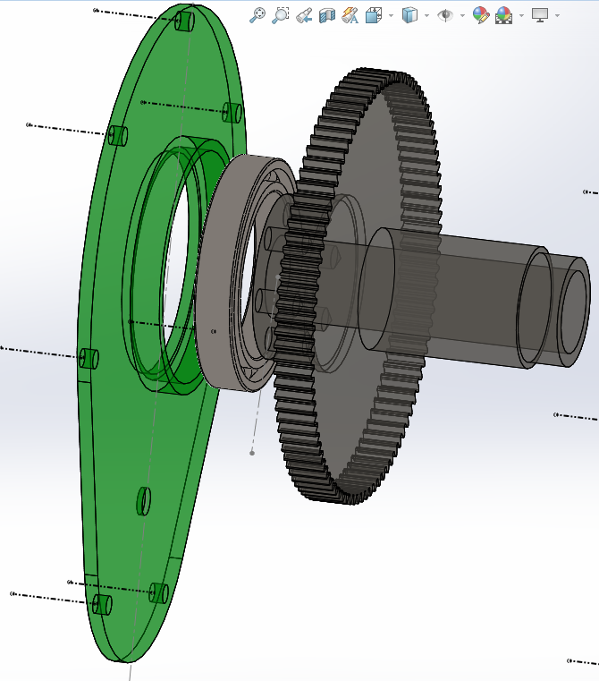

1. Switch to HS3, and using three FS3 screws, mount M1 to HS3, as shown in Figure 13.

Figure 13: Motor mounting

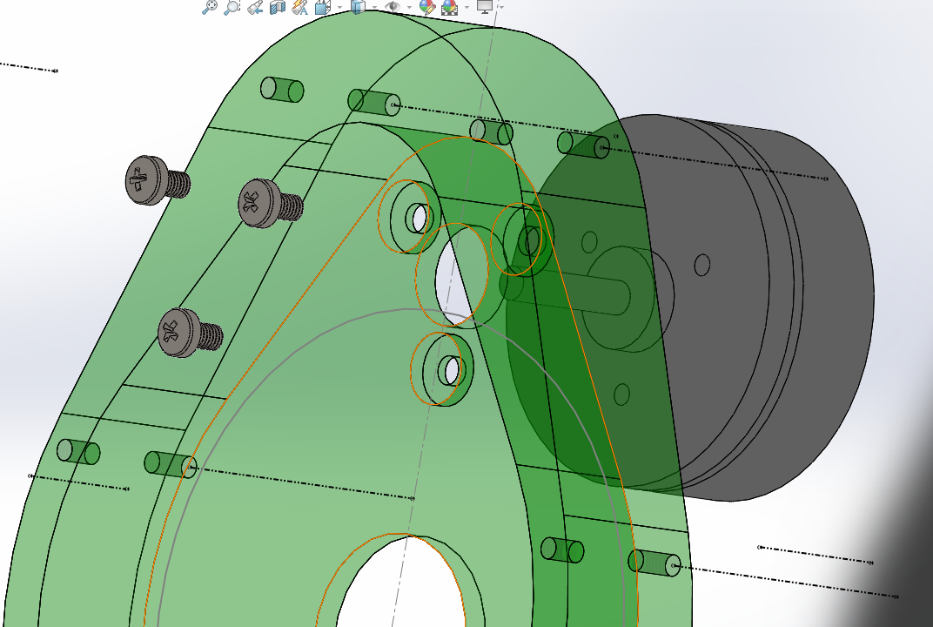

1. Insert the output shaft through the hole in HS3. Slide G1 onto the motor shaft and secure with set screw such that when G1 meshes with G2 it is approximately 1mm from the bottom of HS3, as shown in Figure 14.

Figure 14: Gear Meshing

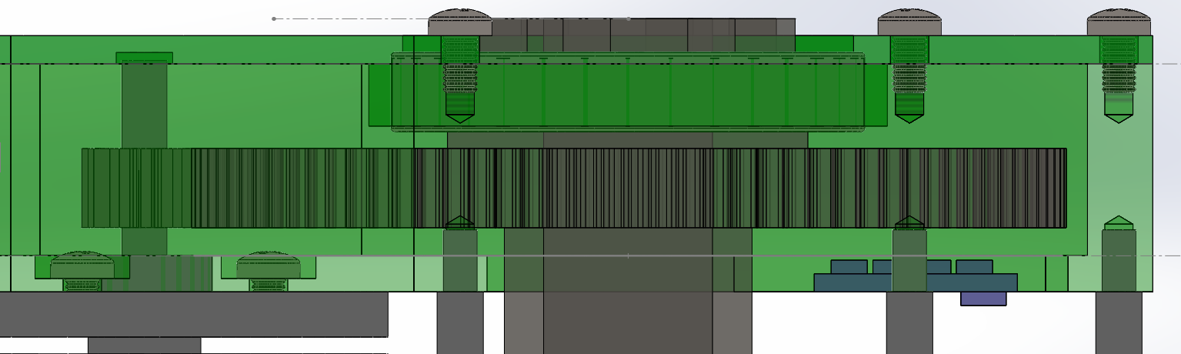

1. Mount HS2 to HS3 ensuring proper gear meshing and secure with 7 FS3 screws, as shown in Figure 15.

Figure 15: Top and middle plate attachment

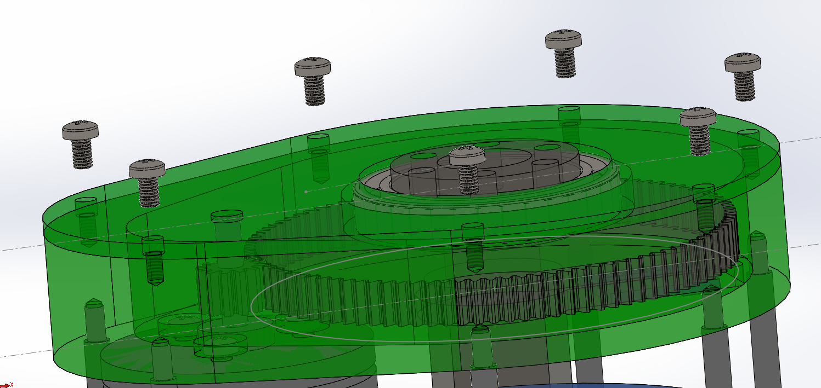

1. Attach PCB2 into the slot in HS3 using 3 FS1.4 screws, as shown in Figure 16.

Figure 16: Encoder board mounting

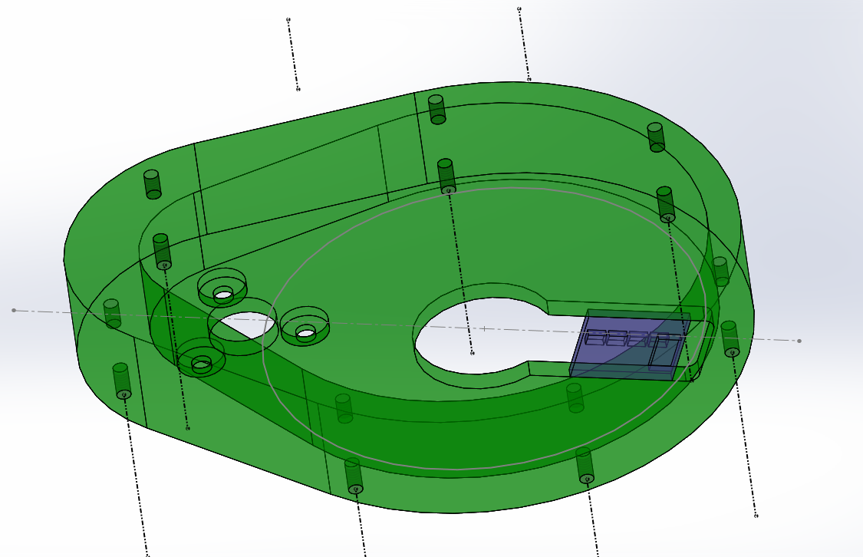

1. Screw the S1s into the seven holes in the base of HS3, as shown in Figure 17.

Figure 17: Standoff attachment

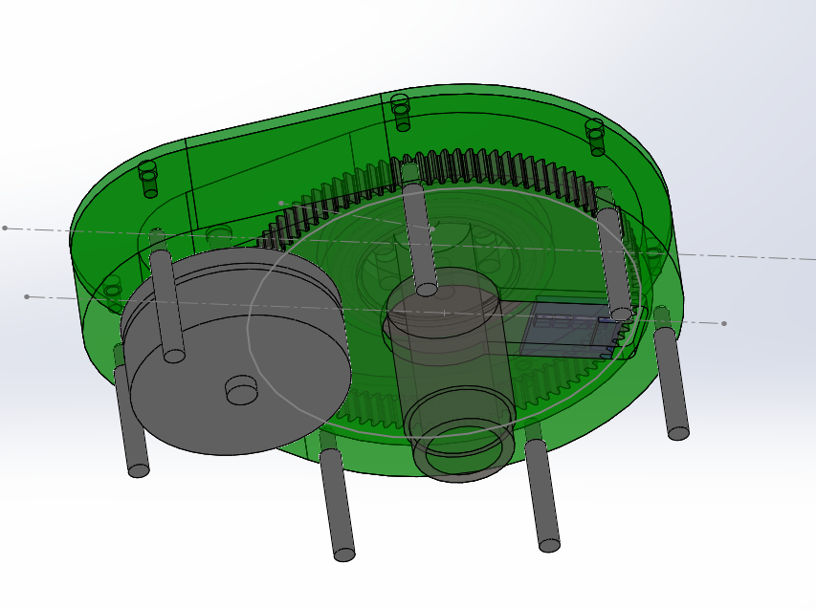

1. Mount PCB1 to the top of HS4 with a dielectric sheet in between it and the surface of the housing plate, using 3 FS1.4 screws, as shown in Figure 18.

Figure 18: Avocado PCB mounting

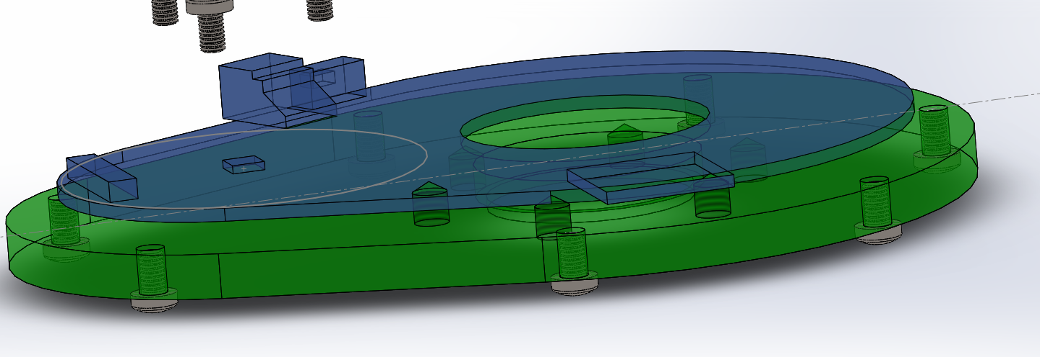

1. Connect the motor cable to the connector on the PCB.
2. Further wire connections can be seen in the [User Guide](Avocado%20User%20Guide%20-%20Final.docx).
3. Press fit B2 into the bearing seat of HS4, as shown in Figure 19.

Figure 19: Bearing in bottom plate

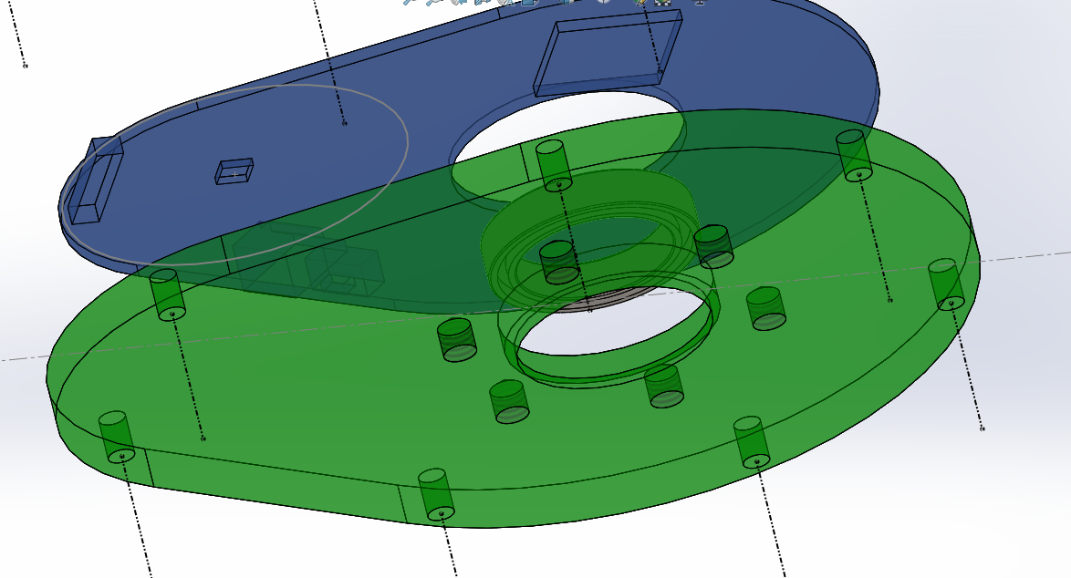

1. Align HS4 to the S1s and secure with seven FS3 screws, as shown in Figure 20.

Figure 20: Bottom plate mounting

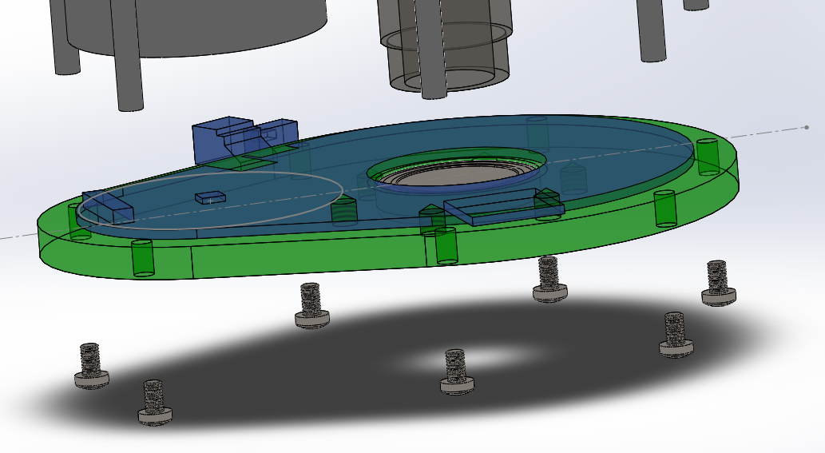

1. You now have a finished Avocado, as shown in Figure 21. An exploded view of the entire Avocado can be seen in Figure 22, and a final drawing of the assembly can be seen in Figure 23 as well as found [here](CAD/StandoffAssem.PDF).

Figure 21: Finished Avocado

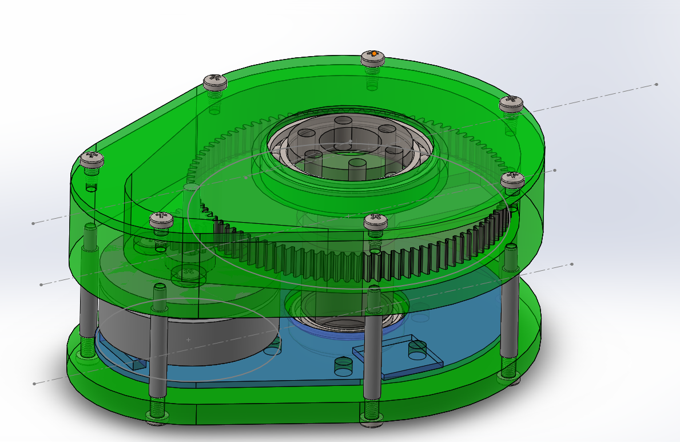

Figure 22: Assembly in Solidworks, exploded

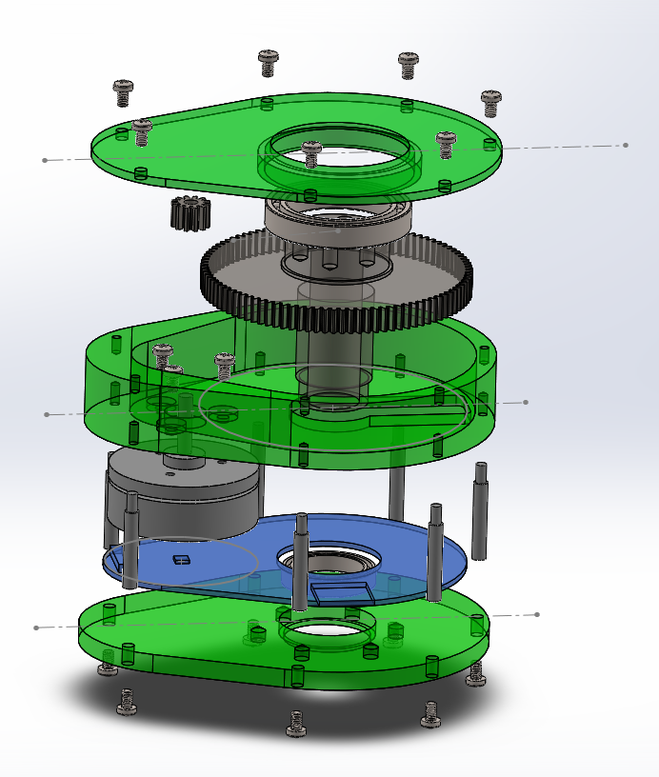

Figure 23: Assembly drawing

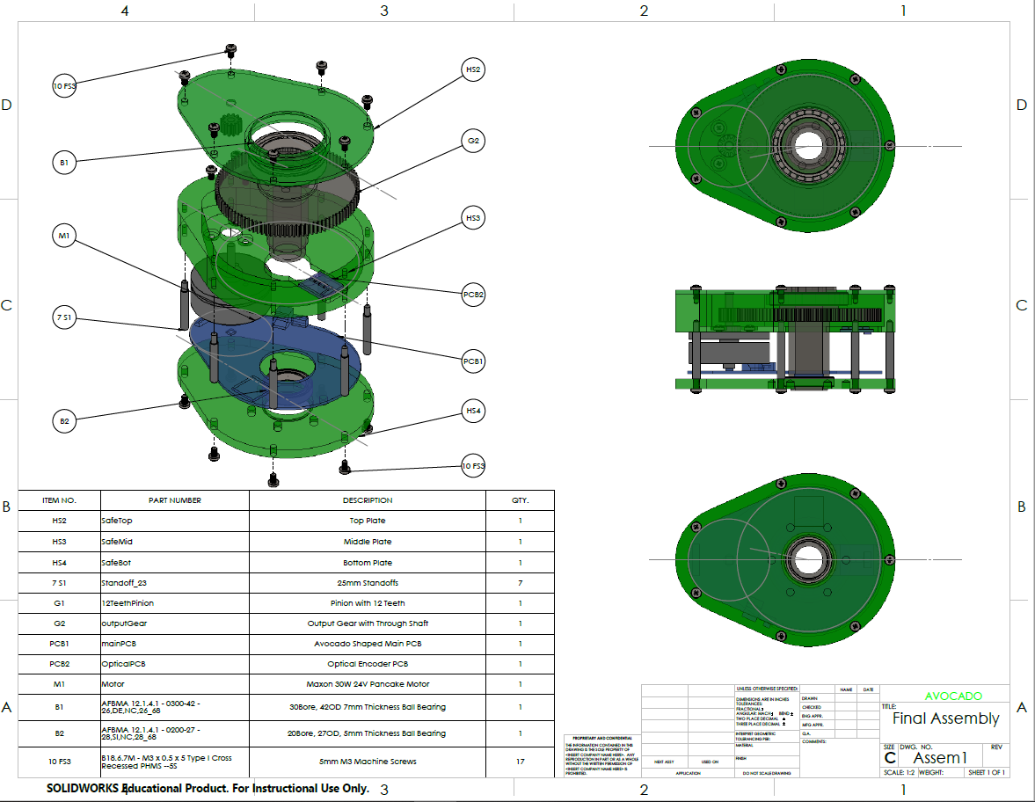

# Bill of Materials

### Mechanical

The list of all mechanical materials used to create one Avocado is listed below in Table 1.

Table 1: Mechanical Bill of Materials

|  |  |  |  |  |  |  |  |  |
| --- | --- | --- | --- | --- | --- | --- | --- | --- |
| **Section** | **Part Number** | **Quantity** | **Item** | **Manufacturing Part No.** | **Manufacturer** | **Price** | **Total Price** | **Vendor** |
| Motor | M1 | 1 | 30 W Flat Brushless Motor | 339281 | Maxon | 85.49 | 85.49 | Maxon |
| Gearing | G1 | 1 | 12 tooth pinion, 32 pitch, 3mm bore | 3942 | Traxxas | 3.26 | 3.26 | Amazon |
| Gearing | G2 | 1 | 96 tooth printed output gear and shaft | n/a | n/a | 12 | 12 | n/a |
| Bearings | B2 | 1 | Deep groove ball bearing, 20x27x4mm | 5182A | Traxxas | 5.49 | 5.49 | Amazon |
| Bearings | B1 | 1 | Deep groove ball bearing, 30x42x7mm | 6806-2RS | VXB | 12.95 | 12.95 | VXB |
| Housing | HS1 | 1 | Housing material | 9246K594 | McMaster Carr | 63.86 | 63.86 | McMaster Carr |
| Housing | FS1.4 | 3 | M1.4 steel screw | n/a | HVAZI | 0.02 | 0.06 | Amazon |
| Housing | FS3 | 10 | M3 steel screw | n/a | HVAZI | 0.02 | 0.2 | Amazon |
| Housing | S1 | 7 | 25mm M3 Male/Female Standoffs | US-SA-AJD-19495 | Amico | 0.3155 | 2.2085 | Amazon |
| Housing | FS5 | 6 | M5 steel screws | n/a | HVAZI | 0.02 | 0.12 | Amazon |
|  |  |  |  |  |  | **Total Price** | **186.43** |  |

### Electrical

The list of all electrical materials used to create one Avocado is listed below in Table 2.

Table 2: Electrical Bill of Materials

|  |  |  |  |  |  |  |  |  |  |
| --- | --- | --- | --- | --- | --- | --- | --- | --- | --- |
| **Section** | **Part Number** | **Quantity** | **Value** | **Item** | **Manufacturing Part No.** | **Manufacturer** | **Price** | **Total Price** | **Vendor** |
| Power Supply | C1, C3 | 2 | 100uF | CAP TANT 100UF 16V 10% 2917 | TPSD107K016R0125 | AVX | $1.12 | $2.24 | Digikey |
| Motor Driver | C10 | 1 | 1uF | CAP CER 1UF 16V X7R 0805 | GRM21BR71C105KA01L | [Murata Electronics North America](https://www.digikey.com/en/supplier-centers/m/murata-electronics) | $0.13 | $0.13 | Digikey |
| Motor Driver | C11 | 1 | 0.047uF | CAP CER 0.047UF 50V X7R 0402 | CGA2B3X7R1H473K050BB | TDK Corporation | 0.12 | 0.12 | Digikey |
| Motor Driver | C13 | 1 | 1uF | CAP CER 1UF 6.3V X5R 0402 | [Murata Electronics North America](https://www.digikey.com/en/supplier-centers/m/murata-electronics) | GRM152R60J105ME15D | $0.31 | $0.31 | Digikey |
| Motor Driver | C14, C15, C34 | 3 | 4.7nF | CAP CER 4700PF 50V X7R 0402 | 04025C472JAT2A | [AVX Corporation](https://www.digikey.com/en/supplier-centers/e/elco) | $0.39 | $1.17 | Digikey |
| Power Supply | C16 | 1 | 0.01 uF | CAP CER 10000PF 50V X7R 0402 | TDK Corporation | C1005X7R1H103K050BB | $0.12 | $0.12 | Digikey |
| Temperature | C19 | 1 | 10uF | CAP CER 10UF 10V X5R 0402 /// CAP CER 10UF 6.3V X5R 0402 | CL05A106MP5NUNC /// C0402C106M9PAC7867 | Samsung Electro-Mechanics /// KEMET | $0.58 | $0.58 | Digikey |
| Power Supply | C2, C4 | 2 | 15uF | CAP TANT 15UF 50V 20% 2917 | TPSE156M050S0250 | AVX | $4.30 | $8.60 | Digikey |
| Oscillators | C22, C23, C24, C25 | 4 | 12pF | CAP CER 12PF 50V C0G/NP0 0402 | C0402C120J5GACTU | [KEMET](https://www.digikey.com/en/supplier-centers/k/kemet) | $0.10 | $0.40 | Digikey |
| MCU | C30 | 1 | 2.2uF | CAP CER 2.2UF 16V X6S 0402 | GRM155C81C225ME15D | Murata Electronics North America | $0.33 | $0.33 | Digikey |
| Encoder | C31, C32 | 2 | 1uF | CAP CER 1UF 25V X7R 0805 | C2012X7R1E105K125AB | [TDK Corporation](https://www.digikey.com/en/supplier-centers/t/tdk) | $0.16 | $0.32 | Digikey |
| Temperature | C35, C37, C16 | 3 | 0.01uF | CAP CER 10000PF 50V X7R 0402 | TDK Corporation | C1005X7R1H103K050BB | $0.12 | $0.36 | Digikey |
| Motor Driver | C38, C39, C40 | 3 | 2200pF | CAP CER 2200PF 25V X7R 0402 | GRM155R71E222KA01D | Murata Electronics North America | $0.10 | $0.30 | Digikey |
| Motor Driver | C41, C42, C43 | 3 | 1uF | CAP CER 1UF 10V X6S 0402 | CGB2A1X6S1A105M033BC | TDK | $0.24 | $0.72 | Digikey |
| Motor Driver | C5, C6, C7 | 3 | 10nF | CAP CER 10000PF 100V X7S 0402 | C1005X7S2A103K050BB | TDK Corporation | $0.13 | $0.39 | Digikey |
| Motor Driver | C50, C51 | 2 | 330uF | CAP ALUM 330UF 20% 63V RADIAL | UPJ1J331MHD6TN | Nichicon | $1.01 | $2.02 | Digikey |
| Motor Driver | C52, C53, C54, C55, C56 | 5 | 22 uF | CAP CER 22UF 50V X7S 3025 | C7563X7S1H226M230LE | [TDK Corporation](https://www.digikey.com/en/supplier-centers/t/tdk) | $6.33 | $31.65 | Digikey |
| Various | C8, C12, C17, C18, C20, C21, C27, C28, C29, C33 | 10 | 0.1 uF | CAP CER 0.1UF 50V X5R 0402 | CGA2B3X5R1H104K050BB | [TDK Corporation](https://www.digikey.com/en/supplier-centers/t/tdk) | $0.13 | $1.29 | Digikey |
| Motor Driver | C9 | 1 | 10uF | CAP CER 10UF 35V X5R 0805 / Multilayer Ceramic Capacitors MLCC - SMD/SMT 0805 35V 10uF X5R 20% T: 1.25mm | GMK212BBJ106KG-T /  C2012X5R1V106M125AC | Taiyo Yuden / TDK | $0.77 | $0.77 | Digikey/Mouser |
| Power Supply | D1, D4 | 2 |  | DIODE SCHOTTKY 40V 1A SMB | MBRS140T3G | ON | $0.50 | $1.00 | Digikey |
| Temperature | D2, D3 | 2 |  | DIODE GEN PURP 75V 150MA SOD323F | 1N4148WS | [ON Semiconductor](https://www.digikey.com/en/supplier-centers/o/on-semiconductor) | $0.18 | $0.36 | Digikey |
| Motor Driver | D5 | 1 | RED | LED RED DIFFUSED 0603 SMD | LS Q976-NR-1 | [OSRAM Opto Semiconductors Inc.](https://www.digikey.com/en/supplier-centers/o/osram-opto-semiconductors) | $0.35 | $0.35 | Digikey |
| Power Supply | D6 | 1 |  | LED GREEN CLEAR 0603 SMD | 150060GS75000 | Wurth | $0.14 | $0.14 | Digikey |
| Temperature | FB1, FB2 | 2 | 2.2kOhm | FERRITE BEAD 2.2 KOHM 0805 1LN | [Wurth Electronics Inc.](https://www.digikey.com/en/supplier-centers/w/wurth-electronics) | 742792093 | $0.20 | $0.40 | Digikey |
| MCU | IC1 | 1 |  | IC MCU 32BIT 1MB FLASH 128TQFP | TM4C1294NCPDTT3 | TI | $15.54 | $15.54 | Digikey |
| Temperature | IC3 | 1 |  | Sensor Interface Thermocouple To Digital Converter | [Maxim Integrated](https://www.mouser.com/maxim-integrated/) | MAX31855KASA+ | $4.49 | $4.49 | Mouser |
| RS485 | IC4 | 1 |  | DG ISO 2.5KV RS422/RS485 16SOIC | ISO3088DW | TI | $7.54 | $7.54 | Digikey |
| Temperature | J1 | 1 |  | Thermocouple Type-K Glass Braid Insulated - K | Adafruit | Thermocouple Type-K Glass Braid Insulated - K | $9.95 | $9.95 | Adafruit |
| Power Supply | L1 | 1 | 150 uH | FIXED IND 150UH 700MA 518 MOHM | SRU1028-151Y | Bourns | $0.91 | $0.91 | Digikey |
| Power Supply | L2 | 1 | 47 uH | FIXED IND 47UH 1.55A 95 MOHM SMD | B82464G4473M000 | EPCOS (TDK) | $2.54 | $2.54 | Digikey |
| Encoder | OPTBIT0, OPTBIT1, OPTBIT2, OPTBIT3 | 4 |  | SENSOR OPTO TRANS REFL SMD PHOTO | QRE1113GR | ON | $1.01 | $4.04 | Digikey |
| Power Supply | P-U5 | 1 | Male | CONN HEADER VH TOP 2POS 3.96MM | B2P-VH(LF)(SN) | JST Sales America Inc. | $0.19 | $0.19 | Digikey |
| Power Supply | R1, R2 | 4 | 330Ohm | RES SMD 330 OHM 1% 1/16W 0402 | RC0402FR-07330RL | [Yageo](https://www.digikey.com/en/supplier-centers/y/yageo) | $0.10 | $0.40 | Digikey |
| Oscillators | R14 | 1 | 2kOhm | RES SMD 2K OHM 5% 1/10W 0402 | Panasonic | ERJ-2GEJ202X | $0.10 | $0.10 | Digikey |
| RS485 | R16 | 1 | 120Ohm | RES SMD 120 OHM 5% 0.4W 0805 | ESR10EZPJ121 | [Rohm Semiconductor](https://www.digikey.com/en/supplier-centers/r/rohm-semi) | $0.10 | $0.10 | Digikey |
| Encoder | R19, R27, R29, R31 | 4 | 100Ohm | RES SMD 100 OHM 1% 1/10W 0402 | MCS0402MC1000FE000 | [Vishay Beyschlag](https://www.digikey.com/en/supplier-centers/v/vishay) | $0.30 | $1.20 | Digikey |
| MCU | R22 | 1 | 1000000 | RES SMD 1M OHM 5% 1/5W 0402 | RCS04021M00JNED | Vishay Dale | $0.12 | $0.12 | Digikey |
| MCU | R24 | 1 | 4.87kOhm 1% | RES SMD 4.87K OHM 1% 1/10W 0402 | [Panasonic Electronic Components](https://www.digikey.com/en/supplier-centers/p/panasonic) | ERJ-2RKF4871X | $0.10 | $0.10 | Digikey |
| MCU | R25 | 1 | 0 ohm | RES SMD 0 OHM JUMPER 1/10W 0402 | ERJ-2GE0R00X | [Panasonic Electronic Components](https://www.digikey.com/en/supplier-centers/p/panasonic) | $0.10 | $0.10 | Digikey |
| Temperature | R33, R34 | 2 | 100kOhm | RES SMD 10K OHM 0.5% 1/16W 0402 | [Susumu](https://www.digikey.com/en/supplier-centers/s/susumu) | RR0510P-103-D | $0.10 | $0.20 | Digikey |
| Motor Driver | R4, R5, R6 | 3 | 2.21Ohm | RES SMD 2.21 OHM 1% 1/8W 0805 | CRCW08052R21FKEA | [Vishay Dale](https://www.digikey.com/en/supplier-centers/v/vishay-dale) | 0.1 | 0.3 | Digikey |
| Various | R7, R12, R18, R20, R28, R30, R32 | 7 | 10kOhm | RES 10K OHM 0.1% 1/10W 0402 | TNPW040210K0BEED | [Vishay Dale](https://www.digikey.com/en/supplier-centers/v/vishay-dale) | $0.65 | $4.55 | Digikey |
| Motor Driver | R8 | 1 | 1.5kOhm | RES 1.5K OHM 0.5% 1/5W 0402 | MCS0402PD1501DE500 | Vishay Beyschlag | $0.63 | $0.63 | Digikey |
| Motor Driver | R9, R10, R11 | 3 | 14mOhm | RES 0.014 OHM 1% 2W 2512 | WSL2512R0140FEA18 | [Vishay Dale](https://www.digikey.com/en/supplier-centers/v/vishay-dale) | $1.78 | $5.34 | Digikey |
| Encoder | U1 | 2 |  | CONN WIRE TO BOARD RA 6POS | 5040500691 | Molex | $1.37 | $2.74 | Digikey |
| Temperature | U1 | 1 |  | SENSOR TEMP ANLG VOLT SC-70-5 | LMT87DCKT | TI | $0.84 | $0.84 | Digikey |
| Motor Driver | U10, U11, U12 | 3 | 40Vds | 40 V Half-Bridge NexFET™ Power Block | **CSD88584Q5DC** | TI | 4.75 | 14.25 | Digikey |
| RS485 | U17 | 1 |  | SWITCH SLIDE SPDT 300MA 6V | MHSS1105 | APEM | $0.54 | $0.54 | Digikey |
| Encoder | U2 | 1 |  | Board Mount Hall Effect / Magnetic Sensors 14-bit rotary position sensor | AS5048A-HTSP | AMS | $6.20 | $6.20 | AMS |
| Motor Driver | U3 | 1 |  | CONN FFC FPC TOP 11POS 1MM R/A | WM3379CT-ND | Molex | $1.31 | $1.31 | Digikey |
| Oscillators | U4 | 1 |  | CRYSTAL 25.0000MHZ 8PF SMD | NX3225GA-25.000M-STD-CRG-2 | NDK | $0.64 | $0.64 | Digikey |
| RS485 | U5 | 2 |  | CONN HEADER PA 3POS SIDE 2MM TIN | S03B-PASK-2 | JST | $0.44 | $0.88 | Digikey |
| Power Supply | U7 | 1 |  | IC REG BUCK 5V 0.5A 8-SOIC | LM2594MX-5.0/NOPB | TI | $3.28 | $3.28 | Digikey |
| Power Supply | U8 | 1 |  | IC REG BUCK 3.3V 1A 8SOIC | LM2675MX-3.3/NOPB | TI | $4.37 | $4.37 | Digikey |
| Motor Driver | U9 | 1 | - | 60V THREE-PHASE SMART GATE DRIVE | DRV8323SRTAT | TI | 4.52 | 4.52 | Digkey |
| RS485 | W2 | 1 | Female | CONN HOUSING PA 3POS 2MM WHITE | PAP-03V-S | [JST Sales America Inc.](https://www.digikey.com/en/supplier-centers/j/jst) | $0.16 | $0.16 | Digikey |
| RS485 | W3 | 1 | Male | CONN HOUSING PAL 3POS 2MM WHITE | PALR-03VF | [JST Sales America Inc.](https://www.digikey.com/en/supplier-centers/j/jst) | $0.15 | $0.15 | Digikey |
| Power Supply | W4 | 1 | Female | CONN HOUSING VH 2POS 3.96MM WHT | VHR-2N | [JST Sales America Inc.](https://www.digikey.com/en/supplier-centers/j/jst) | $0.12 | $0.12 | Digikey |
| MCU | X2 | 1 |  | CRYSTAL 32.7680KHZ 7PF SMD | ABS07-32.768KHZ-7-T | Abracon | $0.71 | $0.71 | Digikey |
|  |  |  |  |  |  |  |  |  |  |
|  |  |  |  |  |  |  |  |  |  |
|  |  |  |  |  | **Total Price** | **150.75** |  |  |  |

The total BOM cost for one Avocado is therefore $337.18.